3GPP TSG RAN WG1 Meeting #83 R1-157435
Anaheim, USA, 15th - 22th November 2015
______________________________________________________________________Agenda item: 6.2.8.1.1
Source: LG Electronics
Title: Discussion on enhancement for PC5 based V2V resource allocation
Document for: Discussion and Decision
- Introduction
In RAN1 82bis, the following agreements about resource allocation were made,
Agreements:
- The resource allocation principles listed below should be studied for PC5-based V2V (note that other schemes are not precluded):
  - Network control aspect
    - At least when a UE is inside coverage of an eNB on the carrier where PC5 is performed (i.e., Uu and PC5 share the carrier), the eNB controls at least some parameters that affects UE resource selection.
    - When a UE operates PC5 in a carrier where no cell is detected but it is inside coverage of an eNB in another carrier (i.e., different carriers for Uu and PC5), network may control at least some parameters that affects UE resource selection.
      - At least when the PC5 and Uu carriers are allocated to the same operator, RAN1 assumes that eNB has at least some controls. FFS for the other cases.
    - UE autonomous resource selection can be configured for a UE inside network coverage.
    - eNB control above includes
      - Exact resources for transmission or set of resources for UE autonomous selection
      - FFS: other parameters
  - Resource pool
    - The concept of resource pool is introduced at least for the purpose of study.
      - Resource pool is a set of time/frequency resources where PC5 transmission may occur. Note that Rel-12 D2D communication mode 1 uses all the time/frequency resources as data pool.
      - FFS whether Rel-12 resource pool configuration is reused for PC5-based V2V.
    - FFS the number of resource pools configured for a UE
      - The need for defining multiple resource pools should be justified.
      - FFS whether the number of SA pools can be different from the number of data pools and, if can, FFS whether multiple SA pools can be associated with the same data pool.
  - Scheduling assignment
    - Each data transmission is scheduled by an SA.
      - FFS whether SA and Data are not transmitted on separate physical channels:
        - In case of separate channels, study whether SA pool and data pool are orthogonal or can overlap.
      - FFS whether SA and data from a single transmitter can be transmitted in the same subframe
    - Study the number of transmissions of a given TB
    - Study the number of transmissions of a given SA
    - FFS whether a single SA may schedule multiple TBs
    - FFS whether the time/frequency resources of a given SA is independent of the time/frequency resources of the associated data
  - Enhancement to resource selection/structure
    - Study which of the following principle(s) is(are) beneficial:
    - Collision avoidance
      - A UE identifies the resources that will be occupied and/or collided by the other UEs and avoids a colliding resource allocation for its transmission.
      - FFS
        - Details of the identification of the occupied and/or collided resources, e.g., by reading other UEs’ SA and/or sensing the energy level
        - How to select the resources and MCS for transmission
        - Whether a UE performs the resource selection procedure for every transmission, and if not, what triggers reselection
          - FFS if the initial selection and reselection procedures are the same or not
        - Whether signaling from eNB (e.g., information on the resource load) or another UE is beneficial.
        - Whether resource in this context is in the physical domain or the logical domain
    - Resource selection based on transmitter-specific information
      - Example 1: Resource allocation based on the location, velocity, and/or direction of the transmitter and/or distance between vehicles.
      - Example 2: A UE reports its observation on the radio environment to help eNB scheduling
    - Enhanced resource randomization
      - Example is increasing the number of time resource patterns.
    - Introducing a finer time resource granularity and/or a coarser frequency resource granularity
    - Semi-persistent scheduling from eNB for PC5 transmissions
    - Cross-carrier scheduling
      - eNB sends control via a carrier to schedule sidelink resource in another carrier not associated with the carrier used for the control transmission.
      - FFS in which scenario(s) this principle is beneficial
  - Differentiation of radio transmission characteristics based at least on higher layer properties
    - FFS which other aspect(s) will also differentiate radio transmission characteristics
    - FFS radio transmission characteristics
  - Transmission power control and/or setting
    - Use different transmission power e.g., depending on scenario
      - This includes the possibility of using zero power (i.e., muting)
  - Resource allocation robust to temporal interruption due to, e.g., handover, RLF, cell reselection
- Assumptions for further study:
  - Tradeoff between system and link level performance can be studied.
  - Assumption on the target link budget in link level:
    - 150 m in NLOS Urban case
    - 320 m in Freeway case
In this contribution, we discuss enhancement for PC5 based V2V resource allocation.
- Discussions
  - Location based resource allocation
Location based resource allocation can have performance gain regardless of resource allocation methods; centralized vs. distributed or sensing vs. randomization. V2V operations are basically location dependent and the optimal radio parameters such as transmission power, repetition number, carrier sensing threshold and so on are also location dependent. If the vehicle intensity/speed is different across vehicle directions/lanes, different interference level may be observed across different vehicle directions/lanes and the optimal radio parameters will be different. We note that the principle of location based resource allocation is independent of the selection between sensing vs. randomization
Fig. 1 illustrates an example of resource pool adaptation scheme in an intersection area. In the agreed channel model for PC5-based V2V evaluation, the pathloss will be changed from LOS to NLOS when turning around corner. In this figure, most of UEs in UE group A will have NLOS channel for UEs in UE group B. However, the pathloss between UEs in the same group will be LOS. This means significant reception power difference will be observed if UE group A and B use same resource pool. Due to the large reception power difference, the weak signals (different group UE’s signal) can be suffered from in-band emission interference of the strong signals (same group UE’s signal). To solve this issue, TDMed resource pool partitioning between different UE groups can be considered as illustrated in this figure. eNB or RSU can configure the boundary to apply the resource pool adaptation.
Fig. 1 An example of transmission resource pool adaptation in an intersection area
Fig. 2 illustrates that the resource pool is separated according to UE moving direction. For the different direction, it is assumed that the resource pool is separated. This operation can be beneficial in that different QoS such as the target range and message reliability can be provided in adaptation to the vehicle density and speed in each direction. To be specific, when the vehicle density is very different in the two directions of a street, it is possible to relax the service quality in the dense direction as the overall vehicle speed is low. However, high service quality should be maintained in the direction with low vehicle density. When the UEs in the two directions use the same resource pool, the same service quality will be provided, but this is not desirable especially when vehicles in the two directions are physically separated and it is not necessary for a vehicle to receive V2V message transmitted from a UE moving in the opposite direction.
Proposal 1: Location based resource allocation should be supported for PC5-based V2V.

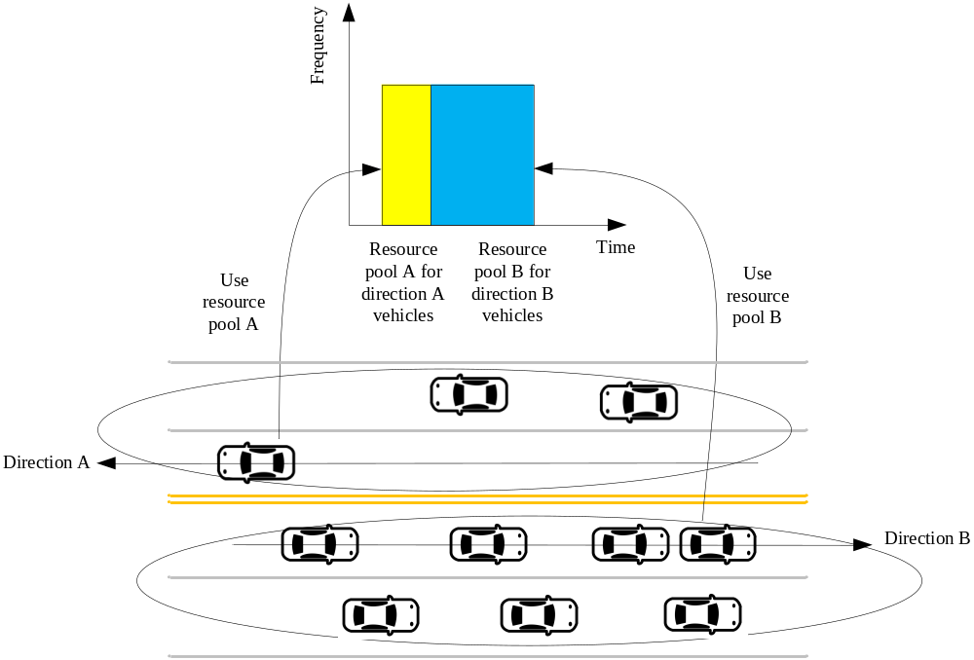
Fig. 2 an example of transmission resource pool adaptation according to direction

  - Consideration on long term (semi-persistent ) resource allocation
In SA1 TR [1], it is assumed that the loss of each message is independent. If long term (semi-persistent) resource allocation is applied, (here, we note that “long term” or “semi-persistent” means having longer scheduling period than message generation period. For example, message generation period is 100ms but resource allocation is maintained for 1s.) RAN1 could have different assumption with SA1. If network can fully control the collision, such resource allocation may not be an issue, but in distributed resource allocation, it is not desirable to have correlated packet loss between each generated messages. Therefore, in UE autonomous resource selection, when each message is transmitted, performing the resource allocation independently should be a baseline.
Proposal 2: In UE autonomous resource selection, when each message is transmitted, performing the resource allocation independently should be a baseline.
  - Detailed enhancements for resource selection mechanism
    - Sensing based resource selection
To reduce resource collision, a sensing based collision avoidance mechanism can be considered, e.g., a UE reads other UE’s control information in order to avoid using the same resource for its transmission. As a UE anyway needs to blindly detect other UEs’ control information for message receptions, impact on the UE implementation would not be a big problem in introducing such a collision avoidance scheme. The details of resource pool structure and control signaling method for sensing based resource is discussed in our companion contribution [2].
    - Random selection with enhanced randomization
Since PC5 based V2V has challenging performance requirement, it has been observed that rel. 12 D2D resource allocation is not sufficient. In rel. 12 D2D, randomization is a basic principle. Time and frequency resources are randomly selected by UE (in Mode 2) and there are 108 time resource patterns (T-RPTs) in FDD. In PC5 based V2V, time and frequency resource collision can be a more serious issue because packet size is increased and there is a large number of UEs in target coverage in dense UE deployment scenario such as urban. One possible enhancement is to increase the number of T-RPTs. However, new T-RPT design may have significant specification impact as well as signaling overhead for each UE. Therefore, it is desirable that randomized T-RPT repetition can be a potential solution for enhanced randomization. The details of resource pool structure and control signaling method for enhanced randomization is discussed in our companion contribution [2].
Proposal 3: Sensing based resource allocation or enhanced randomization can be considered as potential enhancement for PC5 based V2V resource allocation.
  - Evaluation results
We compare random resource allocation, random resource allocation + location based resource partitioning, sensing based resource allocation, and sensing based + location based resource partitioning.
For location based resource partitioning, we consider TDMed resource pool partitioning. In freeway case, resource partitioning method is illustrated in Fig. 3. In urban case, vertical roads use even subframe and horizontal roads use odd subframe.
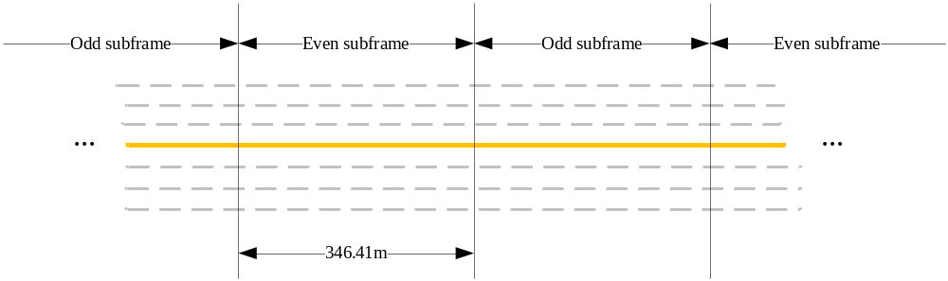
Fig. 3 TDMed resource pool partitioning method for freeway case
For sensing based resource allocation, our sensing operation (we call this method “UE Resource Selection with Collision Avoidance (URS-CA).) is summarized as follows,
- A UE always monitors control channels of other UEs except in a subframe in which it is transmitting.
- When the UE has a message to be transmitted, it selects a random value in the range of [0, (CW-1)]. The counter is set to the selected value.
- In each subframe, the UE counts the number of unoccupied sub-channels. Here, a sub-channel is assumed to be occupied if the UE received in a previous subframe a control channel which schedules data transmission on the sub-channel of the current subframe.
- The UE decrease the counter by the number of unoccupied sub-channels.
- If the counter is equal to or smaller than zero, then the UE starts to transmit the message using a randomly selected unoccupied sub-channel. If not, the UE moves to the next subframe and repeats the procedure (3).
In all simulations, it is assumed control channel containing 30-bit SA is transmitted in a PRB pair in a subframe before the corresponding data transmissions. A modified PUSCH structure (method 2 in [4]) for both of control and data is used. It is assumed that 50 RB system bandwidth is divided into 5 sub-channels, each of which has 10 RBs, and control and data are always transmitted in the same sub-channel. Periodic V2V traffic model is used and a UE always uses one sub-channel in a subframe. 190 byte message and 300 byte message are transmitted using 2 and 3 consecutive subframes, respectively. For URS-CA, it is assumed that the value of ‘CW’ is set to 40ms.
Evaluation results shows TDMed resource pool partitioning has significant performance gain compared with random resource allocation. URS-CA and TDMed resource pool partitioning with URS-CA also have performance gain. It is observed that in freeway case, TDMed resource pool partitioning with URS-CA scheme almost achieves the target performance requirement, however, in urban case, there is still performance gap between the requirement and achievement. To reduce this gap in urban case, options discussed in [3] can be considered.
We also performed the evaluations for the scenario illustrated in Fig. 4 (i.e., SA pool is FDMed with data pool [2]) and the evaluation results are provided in Appendix A. In this evaluation, it is assumed that the (repetition) number of SA transmissions for a data transmission is ‘2’ and SA hopping as in Rel-12 is applied. From these evaluation results in Appendix A, it can be also observed that TDMed resource pool partitioning has a performance gain compared with random resource allocation.
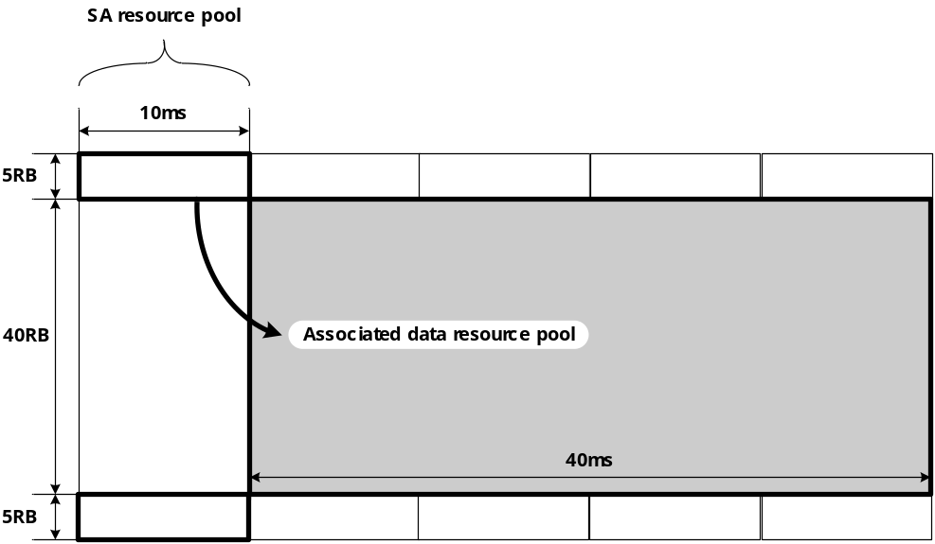
Fig. 4 Evaluations scenario where SA pool is FDMed with data pool
Observation 1: Sensing based resource allocation and location based resource pool partitioning have significant performance gain.
Observation 2: In urban case, achieving the target performance requirement seems challenging, so additional methods such as network control of transmission parameter, use of multi-carrier, use of Uu interface can be considered.

Table 1. Average PRR in the freeway case (140km/h)
Range (m) | Random resource selection | URS-CA | Gain [%] | TDMed resource pool partitioning w/ random resource selection | Gain [%] | TDMed resource pool partitioning w/ URS-CA | Gain [%]
0 ~ 20 | 0.9564 | 0.9653 | 0.93 | 0.9105 | -4.79 | 0.9318 | -2.57
20 ~ 40 | 0.9433 | 0.9686 | 2.69 | 0.8943 | -5.19 | 0.9375 | -0.61
40 ~ 60 | 0.9261 | 0.9516 | 2.75 | 0.8796 | -5.03 | 0.9194 | -0.73
60 ~ 80 | 0.9097 | 0.9428 | 3.63 | 0.8536 | -6.17 | 0.9087 | -0.11
80 ~ 100 | 0.8878 | 0.9310 | 4.87 | 0.8365 | -5.78 | 0.8980 | 1.15
100 ~ 120 | 0.8634 | 0.9139 | 5.84 | 0.8207 | -4.94 | 0.8831 | 2.28
120 ~ 140 | 0.8463 | 0.8992 | 6.25 | 0.8042 | -4.98 | 0.8798 | 3.95
140 ~ 160 | 0.8319 | 0.8820 | 6.02 | 0.7999 | -3.85 | 0.8665 | 4.15
160 ~ 180 | 0.8009 | 0.8613 | 7.54 | 0.7974 | -0.44 | 0.8689 | 8.49
180 ~ 200 | 0.7794 | 0.8478 | 8.78 | 0.8012 | 2.79 | 0.8717 | 11.84
200 ~ 220 | 0.7543 | 0.8293 | 9.95 | 0.8214 | 8.89 | 0.8695 | 15.27
220 ~ 240 | 0.7365 | 0.8113 | 10.15 | 0.8303 | 12.73 | 0.8883 | 20.60
240 ~ 260 | 0.7128 | 0.7954 | 11.58 | 0.8386 | 17.64 | 0.8875 | 24.50
260 ~ 280 | 0.6900 | 0.7882 | 14.23 | 0.8484 | 22.95 | 0.8978 | 30.11
280 ~ 300 | 0.6731 | 0.7625 | 13.27 | 0.8509 | 26.41 | 0.8954 | 33.03
300 ~ 320 | 0.6549 | 0.7428 | 13.43 | 0.8469 | 29.32 | 0.9019 | 37.72
320 ~ 340 | 0.6380 | 0.7346 | 15.14 | 0.8409 | 31.80 | 0.9029 | 41.52
340 ~ 360 | 0.6296 | 0.7162 | 13.74 | 0.8295 | 31.73 | 0.8892 | 41.23
360 ~ 380 | 0.6134 | 0.7053 | 14.98 | 0.7998 | 30.39 | 0.8674 | 41.42
380 ~ 400 | 0.5984 | 0.6998 | 16.95 | 0.7753 | 29.56 | 0.8441 | 41.06
400 ~ 420 | 0.5775 | 0.6816 | 18.04 | 0.7326 | 26.87 | 0.8046 | 39.33
420 ~ 440 | 0.5577 | 0.6627 | 18.82 | 0.6971 | 24.99 | 0.7704 | 38.13
440 ~ 460 | 0.5440 | 0.6509 | 19.64 | 0.6634 | 21.95 | 0.7180 | 31.98
460 ~ 480 | 0.5332 | 0.6206 | 16.39 | 0.6000 | 12.54 | 0.6882 | 29.07
480 ~ 500 | 0.5072 | 0.6146 | 21.18 | 0.5637 | 11.15 | 0.6440 | 26.97
500 ~ 520 | 0.4840 | 0.5898 | 21.87 | 0.5201 | 7.46 | 0.5988 | 23.73

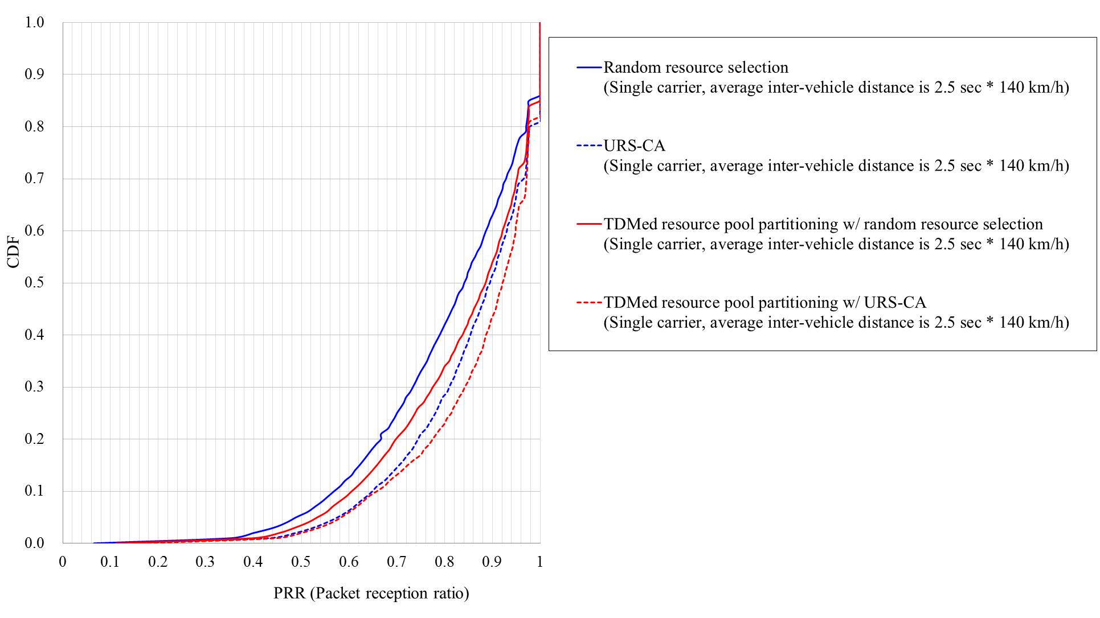

Fig. 5 CDF of PRR in the range of [0, 320]m (i.e., freeway case, 140km/h)

Table 2. Average PRR in the freeway case (70km/h)
Range (m) | Random resource selection | URS-CA | Gain [%] | TDMed resource pool partitioning w/ random resource selection | Gain [%] | TDMed resource pool partitioning w/ URS-CA | Gain [%]
0 ~ 20 | 0.9537 | 0.9611 | 0.78 | 0.9080 | -4.79 | 0.9293 | -2.55
20 ~ 40 | 0.9328 | 0.9530 | 2.16 | 0.8781 | -5.87 | 0.9205 | -1.32
40 ~ 60 | 0.8964 | 0.9318 | 3.96 | 0.8292 | -7.49 | 0.8928 | -0.40
60 ~ 80 | 0.8605 | 0.9071 | 5.42 | 0.7862 | -8.64 | 0.8710 | 1.22
80 ~ 100 | 0.8219 | 0.8773 | 6.74 | 0.7524 | -8.46 | 0.8343 | 1.51
100 ~ 120 | 0.7785 | 0.8456 | 8.62 | 0.7216 | -7.32 | 0.8037 | 3.24
120 ~ 140 | 0.7338 | 0.8175 | 11.39 | 0.7015 | -4.41 | 0.7899 | 7.64
140 ~ 160 | 0.6974 | 0.7876 | 12.94 | 0.7012 | 0.55 | 0.7824 | 12.20
160 ~ 180 | 0.6625 | 0.7655 | 15.55 | 0.6917 | 4.40 | 0.7698 | 16.19
180 ~ 200 | 0.6284 | 0.7368 | 17.26 | 0.6984 | 11.14 | 0.7690 | 22.38
200 ~ 220 | 0.5984 | 0.7044 | 17.72 | 0.6940 | 15.98 | 0.7674 | 28.23
220 ~ 240 | 0.5599 | 0.6701 | 19.67 | 0.6927 | 23.70 | 0.7664 | 36.87
240 ~ 260 | 0.5374 | 0.6436 | 19.76 | 0.7197 | 33.91 | 0.7789 | 44.93
260 ~ 280 | 0.5009 | 0.6085 | 21.48 | 0.7131 | 42.36 | 0.7818 | 56.08
280 ~ 300 | 0.4786 | 0.5843 | 22.09 | 0.7187 | 50.17 | 0.7890 | 64.86
300 ~ 320 | 0.4458 | 0.5520 | 23.83 | 0.7072 | 58.62 | 0.7810 | 75.20
320 ~ 340 | 0.4217 | 0.5232 | 24.07 | 0.6942 | 64.62 | 0.7612 | 80.52
340 ~ 360 | 0.3917 | 0.4955 | 26.50 | 0.6678 | 70.47 | 0.7344 | 87.47
360 ~ 380 | 0.3674 | 0.4710 | 28.17 | 0.6205 | 68.86 | 0.6849 | 86.41
380 ~ 400 | 0.3466 | 0.4373 | 26.18 | 0.5690 | 64.18 | 0.6348 | 83.17
400 ~ 420 | 0.3247 | 0.4108 | 26.50 | 0.5243 | 61.47 | 0.5849 | 80.11
420 ~ 440 | 0.3060 | 0.3919 | 28.04 | 0.4676 | 52.78 | 0.5340 | 74.48
440 ~ 460 | 0.2883 | 0.3701 | 28.38 | 0.4233 | 46.83 | 0.4751 | 64.79
460 ~ 480 | 0.2723 | 0.3424 | 25.78 | 0.3767 | 38.35 | 0.4285 | 57.38
480 ~ 500 | 0.2463 | 0.3177 | 29.01 | 0.3348 | 35.96 | 0.3842 | 55.98
500 ~ 520 | 0.2323 | 0.3073 | 32.31 | 0.2871 | 23.62 | 0.3286 | 41.47

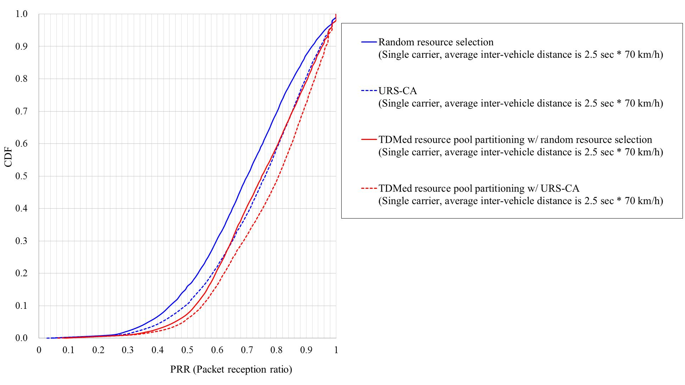

Fig. 6 CDF of PRR in the range of [0, 320]m (i.e., freeway case, 70km/h)

Table 3. Average PRR in the urban case (60km/h)
Range (m) | Random resource selection | URS-CA | Gain [%] | TDMed resource pool partitioning w/ random resource selection | Gain [%] | TDMed resource pool partitioning w/ URS-CA | Gain [%]
0 ~ 20 | 0.9551 | 0.9654 | 1.07 | 0.9127 | -4.44 | 0.9337 | -2.24
20 ~ 40 | 0.9285 | 0.9504 | 2.37 | 0.8808 | -5.14 | 0.9240 | -0.48
40 ~ 60 | 0.8768 | 0.9186 | 4.76 | 0.8472 | -3.38 | 0.9055 | 3.28
60 ~ 80 | 0.8049 | 0.8685 | 7.91 | 0.8013 | -0.45 | 0.8738 | 8.56
80 ~ 100 | 0.7190 | 0.7844 | 9.10 | 0.7503 | 4.36 | 0.8307 | 15.54
100 ~ 120 | 0.6388 | 0.7069 | 10.65 | 0.6814 | 6.66 | 0.7725 | 20.93
120 ~ 140 | 0.5672 | 0.6243 | 10.06 | 0.6088 | 7.32 | 0.6866 | 21.04
140 ~ 160 | 0.5014 | 0.5615 | 11.99 | 0.5266 | 5.03 | 0.5995 | 19.57
160 ~ 180 | 0.4328 | 0.4843 | 11.91 | 0.4495 | 3.88 | 0.5184 | 19.80
180 ~ 200 | 0.3615 | 0.4087 | 13.05 | 0.3759 | 3.98 | 0.4341 | 20.07
200 ~ 220 | 0.3014 | 0.3479 | 15.43 | 0.2985 | -0.98 | 0.3460 | 14.79
220 ~ 240 | 0.2567 | 0.3031 | 18.09 | 0.2229 | -13.16 | 0.2635 | 2.63
240 ~ 260 | 0.1018 | 0.1191 | 17.03 | 0.0905 | -11.11 | 0.1068 | 4.94
260 ~ 280 | 0.0983 | 0.1174 | 19.43 | 0.0855 | -12.99 | 0.1052 | 7.06
280 ~ 300 | 0.1056 | 0.1256 | 18.95 | 0.0881 | -16.58 | 0.1050 | -0.58
300 ~ 320 | 0.1013 | 0.1207 | 19.19 | 0.0856 | -15.46 | 0.1010 | -0.25
320 ~ 340 | 0.0985 | 0.1178 | 19.56 | 0.0825 | -16.26 | 0.0963 | -2.29
340 ~ 360 | 0.0892 | 0.1098 | 23.05 | 0.0754 | -15.50 | 0.0892 | -0.05
360 ~ 380 | 0.0839 | 0.1054 | 25.61 | 0.0743 | -11.46 | 0.0849 | 1.11
380 ~ 400 | 0.0814 | 0.1002 | 23.11 | 0.0645 | -20.73 | 0.0762 | -6.40
400 ~ 420 | 0.0724 | 0.0872 | 20.42 | 0.0530 | -26.80 | 0.0617 | -14.81
420 ~ 440 | 0.0506 | 0.0609 | 20.34 | 0.0300 | -40.78 | 0.0334 | -34.07
440 ~ 460 | 0.0467 | 0.0560 | 19.94 | 0.0260 | -44.37 | 0.0305 | -34.56
460 ~ 480 | 0.0443 | 0.0522 | 17.88 | 0.0256 | -42.11 | 0.0291 | -34.28
480 ~ 500 | 0.0308 | 0.0361 | 17.23 | 0.0176 | -42.95 | 0.0196 | -36.39
500 ~ 520 | 0.0200 | 0.0234 | 17.01 | 0.0124 | -38.18 | 0.0133 | -33.43

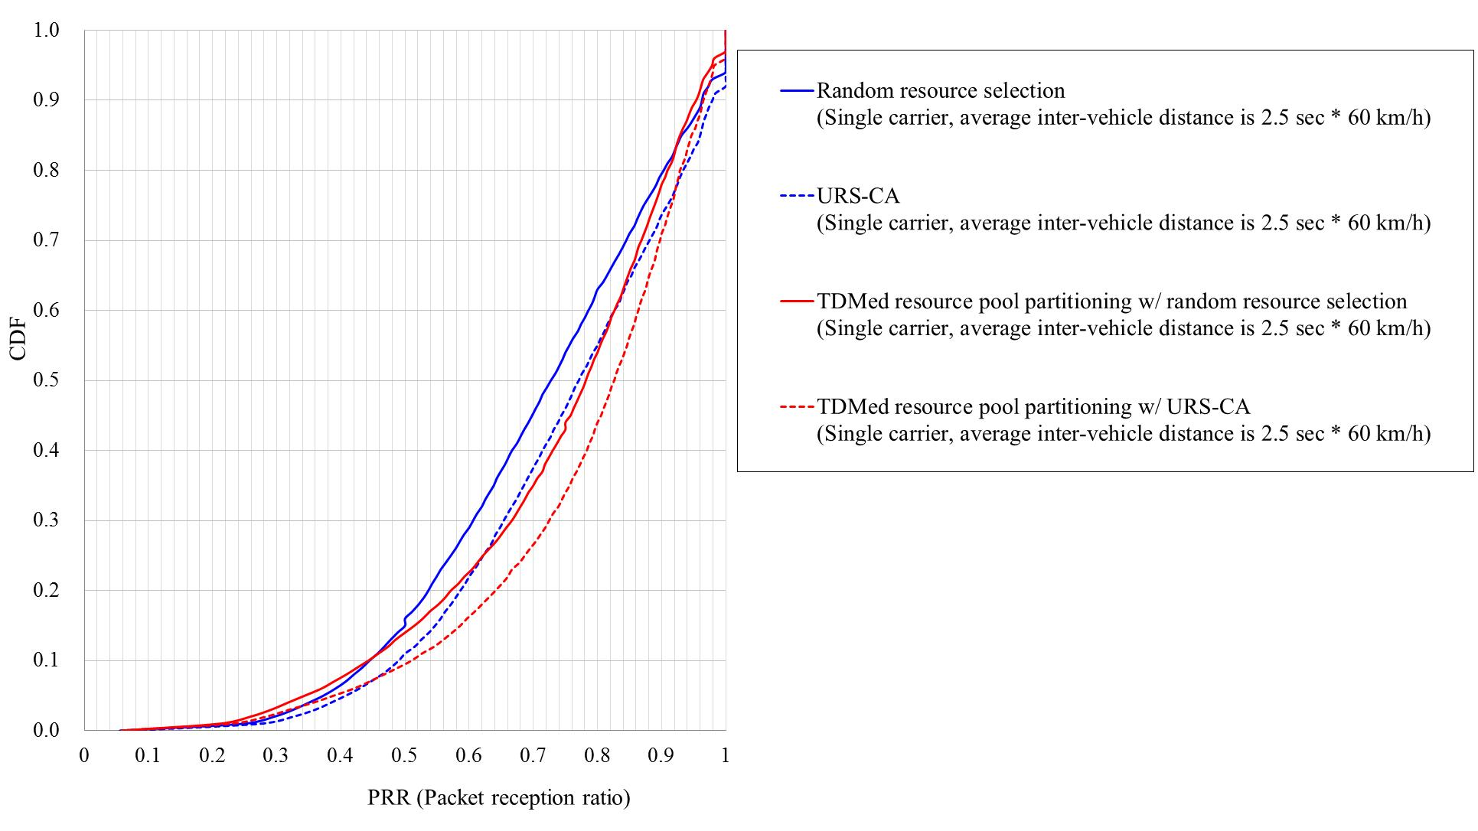

Fig. 7 CDF of PRR in the range of [0, 150]m (i.e., urban case, 60km/h)

Table 4. Average PRR in the urban case (15km/h, message generation period of ‘100ms’)
Range (m) | Random resource selection | URS-CA | Gain [%] | TDMed resource pool partitioning w/ random resource selection | Gain [%] | TDMed resource pool partitioning w/ URS-CA | Gain [%]
0 ~ 20 | 0.9388 | 0.9449 | 0.64 | 0.8881 | -5.41 | 0.9016 | -3.97
20 ~ 40 | 0.8439 | 0.8915 | 5.63 | 0.7612 | -9.80 | 0.8371 | -0.81
40 ~ 60 | 0.6904 | 0.7712 | 11.70 | 0.5955 | -13.75 | 0.7196 | 4.23
60 ~ 80 | 0.5357 | 0.6298 | 17.58 | 0.4569 | -14.71 | 0.5768 | 7.67
80 ~ 100 | 0.3905 | 0.4756 | 21.81 | 0.3498 | -10.42 | 0.4517 | 15.68
100 ~ 120 | 0.2750 | 0.3473 | 26.27 | 0.2741 | -0.35 | 0.3419 | 24.31
120 ~ 140 | 0.2052 | 0.2610 | 27.20 | 0.2105 | 2.59 | 0.2485 | 21.07
140 ~ 160 | 0.1555 | 0.1985 | 27.64 | 0.1645 | 5.78 | 0.1866 | 19.99
160 ~ 180 | 0.1167 | 0.1461 | 25.15 | 0.1307 | 11.95 | 0.1432 | 22.70
180 ~ 200 | 0.0860 | 0.1078 | 25.30 | 0.1036 | 20.36 | 0.1079 | 25.38
200 ~ 220 | 0.0670 | 0.0793 | 18.24 | 0.0780 | 16.38 | 0.0791 | 18.03
220 ~ 240 | 0.0496 | 0.0561 | 12.98 | 0.0459 | -7.59 | 0.0450 | -9.42
240 ~ 260 | 0.0167 | 0.0185 | 10.73 | 0.0198 | 18.48 | 0.0198 | 18.24
260 ~ 280 | 0.0138 | 0.0156 | 12.49 | 0.0168 | 21.13 | 0.0166 | 19.79
280 ~ 300 | 0.0138 | 0.0132 | -4.12 | 0.0170 | 23.62 | 0.0164 | 19.27
300 ~ 320 | 0.0112 | 0.0106 | -5.37 | 0.0192 | 72.15 | 0.0185 | 65.42
320 ~ 340 | 0.0087 | 0.0078 | -10.21 | 0.0194 | 122.35 | 0.0187 | 114.02
340 ~ 360 | 0.0072 | 0.0061 | -14.29 | 0.0190 | 164.85 | 0.0187 | 161.56
360 ~ 380 | 0.0061 | 0.0051 | -16.03 | 0.0149 | 145.96 | 0.0140 | 131.04
380 ~ 400 | 0.0051 | 0.0038 | -24.87 | 0.0112 | 121.27 | 0.0103 | 104.27
400 ~ 420 | 0.0040 | 0.0029 | -27.27 | 0.0069 | 72.09 | 0.0059 | 46.97
420 ~ 440 | 0.0025 | 0.0018 | -29.31 | 0.0024 | -3.58 | 0.0019 | -23.19
440 ~ 460 | 0.0021 | 0.0014 | -32.12 | 0.0014 | -34.35 | 0.0010 | -53.93
460 ~ 480 | 0.0021 | 0.0013 | -38.17 | 0.0016 | -22.81 | 0.0011 | -46.08
480 ~ 500 | 0.0013 | 0.0007 | -49.04 | 0.0016 | 24.41 | 0.0013 | 3.26
500 ~ 520 | 0.0008 | 0.0003 | -55.04 | 0.0017 | 117.60 | 0.0015 | 87.60

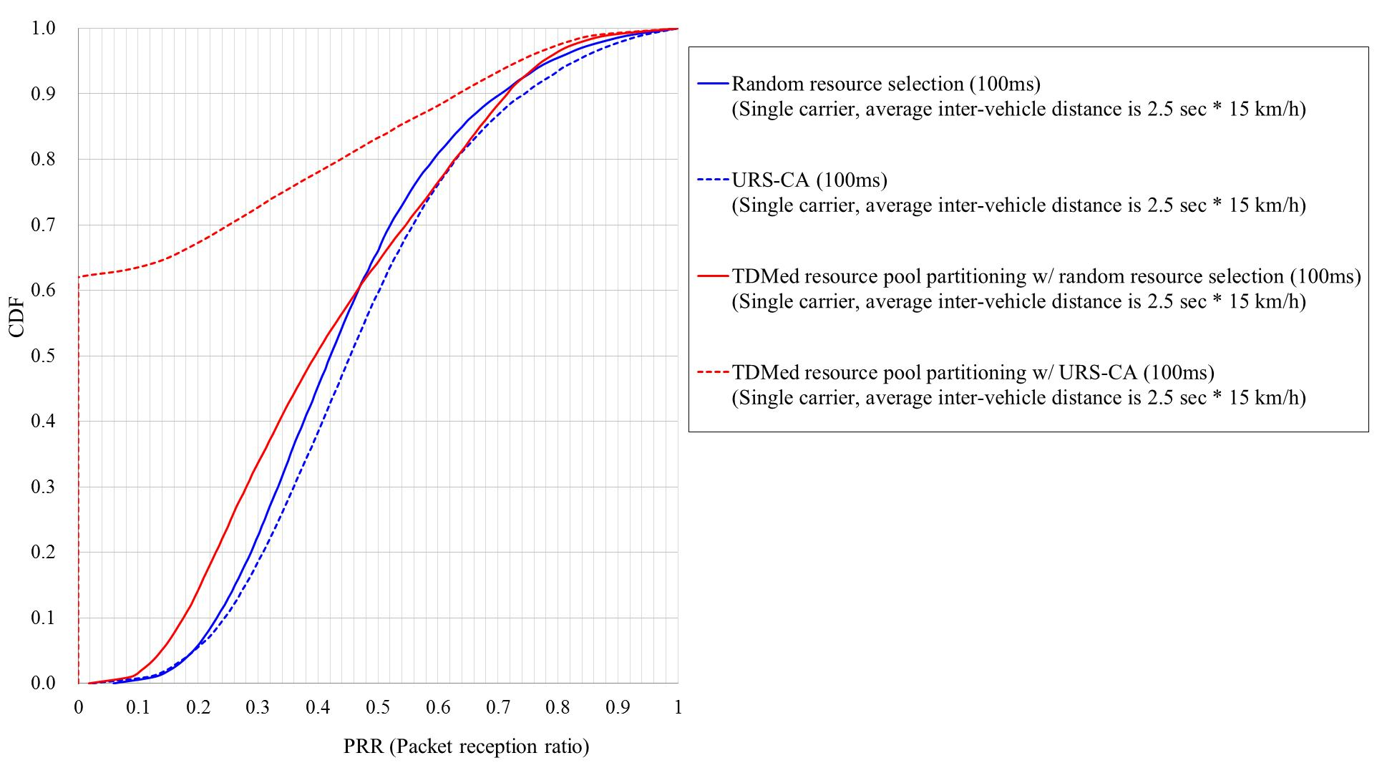

Fig. 8 CDF of PRR in the range of [0, 150]m (i.e., urban case, 15km/h, message generation period of ‘100ms’)

Table 5. Average PRR in the urban case (15km/h, message generation period of ‘500ms’)
Range (m) | Random resource selection | URS-CA | Gain [%] | TDMed resource pool partitioning w/ random resource selection | Gain [%] | TDMed resource pool partitioning w/ URS-CA | Gain [%]
0 ~ 20 | 0.9871 | 0.9910 | 0.39 | 0.9751 | -1.22 | 0.9837 | -0.35
20 ~ 40 | 0.9655 | 0.9811 | 1.61 | 0.9498 | -1.62 | 0.9697 | 0.43
40 ~ 60 | 0.9235 | 0.9544 | 3.35 | 0.9077 | -1.71 | 0.9441 | 2.24
60 ~ 80 | 0.8726 | 0.9175 | 5.14 | 0.8599 | -1.46 | 0.9145 | 4.81
80 ~ 100 | 0.7931 | 0.8479 | 6.91 | 0.8186 | 3.21 | 0.8718 | 9.93
100 ~ 120 | 0.7013 | 0.7579 | 8.07 | 0.7587 | 8.19 | 0.8250 | 17.64
120 ~ 140 | 0.6125 | 0.6623 | 8.13 | 0.6675 | 8.99 | 0.7368 | 20.30
140 ~ 160 | 0.5382 | 0.5940 | 10.37 | 0.5769 | 7.18 | 0.6368 | 18.31
160 ~ 180 | 0.4684 | 0.5215 | 11.34 | 0.4910 | 4.82 | 0.5484 | 17.08
180 ~ 200 | 0.4093 | 0.4599 | 12.35 | 0.4116 | 0.58 | 0.4698 | 14.78
200 ~ 220 | 0.3568 | 0.3970 | 11.26 | 0.3419 | -4.18 | 0.3888 | 8.95
220 ~ 240 | 0.3095 | 0.3461 | 11.85 | 0.2738 | -11.52 | 0.3110 | 0.50
240 ~ 260 | 0.1213 | 0.1366 | 12.60 | 0.1084 | -10.63 | 0.1249 | 2.97
260 ~ 280 | 0.1205 | 0.1377 | 14.27 | 0.1076 | -10.69 | 0.1252 | 3.90
280 ~ 300 | 0.1293 | 0.1478 | 14.27 | 0.1095 | -15.36 | 0.1298 | 0.39
300 ~ 320 | 0.1289 | 0.1480 | 14.79 | 0.1084 | -15.96 | 0.1277 | -0.97
320 ~ 340 | 0.1190 | 0.1386 | 16.46 | 0.1069 | -10.17 | 0.1243 | 4.42
340 ~ 360 | 0.1137 | 0.1313 | 15.50 | 0.1002 | -11.80 | 0.1177 | 3.57
360 ~ 380 | 0.1054 | 0.1225 | 16.25 | 0.0893 | -15.29 | 0.1024 | -2.80
380 ~ 400 | 0.0999 | 0.1168 | 16.86 | 0.0804 | -19.53 | 0.0939 | -6.00
400 ~ 420 | 0.0895 | 0.1056 | 18.08 | 0.0683 | -23.63 | 0.0802 | -10.38
420 ~ 440 | 0.0626 | 0.0736 | 17.52 | 0.0393 | -37.30 | 0.0467 | -25.49
440 ~ 460 | 0.0600 | 0.0704 | 17.25 | 0.0367 | -38.82 | 0.0437 | -27.20
460 ~ 480 | 0.0586 | 0.0715 | 22.14 | 0.0379 | -35.33 | 0.0454 | -22.57
480 ~ 500 | 0.0426 | 0.0487 | 14.13 | 0.0266 | -37.58 | 0.0293 | -31.24
500 ~ 520 | 0.0267 | 0.0301 | 12.82 | 0.0174 | -34.83 | 0.0196 | -26.39

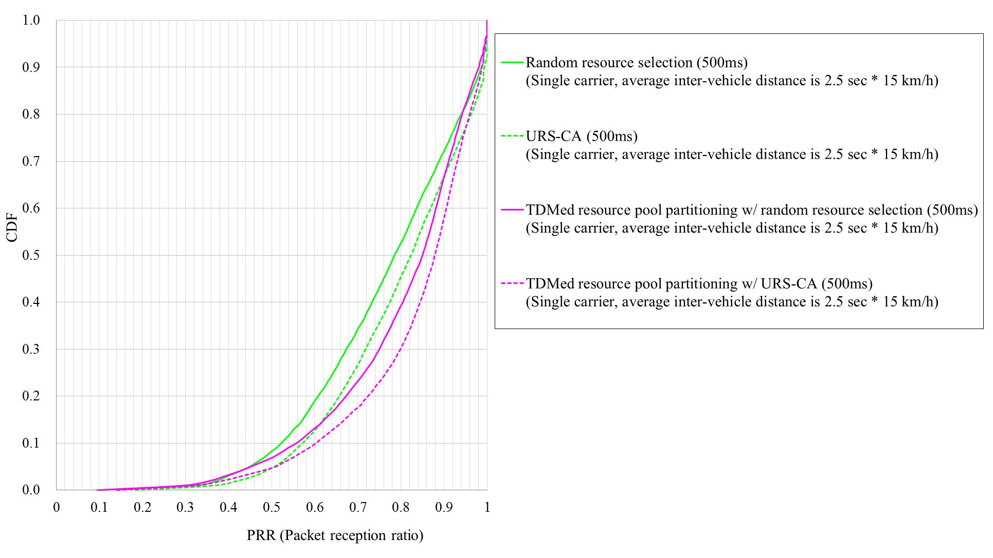

Fig. 9 CDF of PRR in the range of [0, 150]m (i.e., urban case, 15km/h, message generation period of ‘500ms’)

- Conclusion
This contribution discussed enhancement for PC5 based V2V resource allocation. Based on the discussions, the following observation and proposals were made:
Proposal 1: Location based resource allocation should be supported for PC5-based V2V.
Proposal 2: In UE autonomous resource selection, when each message is transmitted, performing the resource allocation independently should be a baseline.
Proposal 3: Sensing based resource allocation or enhanced randomization can be considered as potential enhancement for PC5 based V2V resource allocation.
Observation 1: Sensing based resource allocation and location based resource pool partitioning have significant performance gain.
Observation 2: In urban case, achieving the target performance requirement seems challenging, so additional methods such as network control of transmission parameter, use of multi-carrier, use of Uu interface can be considered.
______________________________________________________________________
Reference
[1] SP-150545, 3GPP TR 22.885 V1.0.0: Study on LTE Support for V2X Services, Sep. 2015.
[2] R1-156892, “Discussion on resource pool structure and control signalling for PC5 based V2V”, LG Electronics.
[3] R1-156893, “Discussion on handling high V2X message load”, LG Electronics.
[4] R1-156894, “Discussion on DMRS density and structure to handle high Doppler case”, LG Electronics.

Appendix A. Evaluatioin results (i.e., SA pool is FDMed with data pool)

Table A-1. Average PRR in the freeway case (140km/h)
Range (m) | Random resource selection | TDMed resource pool partitioning w/ random resource selection | Gain [%]
0 ~ 20 | 0.7951 | 0.7802 | -1.88
20 ~ 40 | 0.7934 | 0.7785 | -1.88
40 ~ 60 | 0.7917 | 0.7710 | -2.62
60 ~ 80 | 0.7843 | 0.7612 | -2.95
80 ~ 100 | 0.7811 | 0.7431 | -4.87
100 ~ 120 | 0.7658 | 0.7283 | -4.90
120 ~ 140 | 0.7558 | 0.7164 | -5.21
140 ~ 160 | 0.7465 | 0.7093 | -4.99
160 ~ 180 | 0.7343 | 0.7005 | -4.60
180 ~ 200 | 0.7210 | 0.7084 | -1.75
200 ~ 220 | 0.7066 | 0.7085 | 0.28
220 ~ 240 | 0.6913 | 0.7240 | 4.73
240 ~ 260 | 0.6691 | 0.7192 | 7.50
260 ~ 280 | 0.6600 | 0.7357 | 11.46
280 ~ 300 | 0.6490 | 0.7445 | 14.71
300 ~ 320 | 0.6285 | 0.7524 | 19.72
320 ~ 340 | 0.6110 | 0.7559 | 23.73
340 ~ 360 | 0.6013 | 0.7519 | 25.04
360 ~ 380 | 0.5841 | 0.7370 | 26.17
380 ~ 400 | 0.5747 | 0.7137 | 24.17
400 ~ 420 | 0.5600 | 0.6861 | 22.51
420 ~ 440 | 0.5559 | 0.6545 | 17.74
440 ~ 460 | 0.5382 | 0.6106 | 13.45
460 ~ 480 | 0.5158 | 0.5815 | 12.76
480 ~ 500 | 0.4986 | 0.5368 | 7.67
500 ~ 520 | 0.4737 | 0.4926 | 3.99

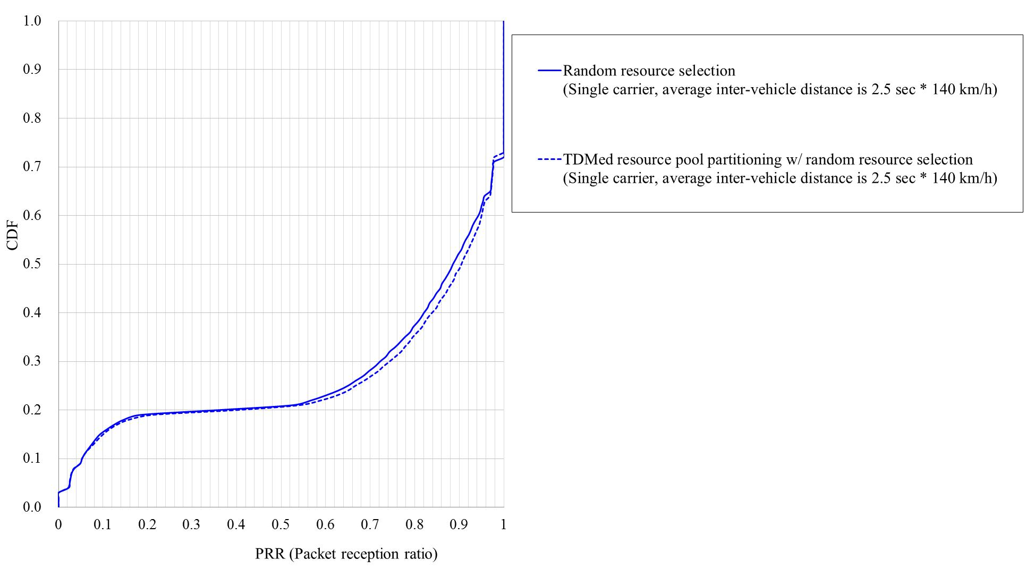

Fig. A-1 CDF of PRR in the range of [0, 320]m (i.e., freeway case, 140km/h)

Table A-2. Average PRR in the freeway case (70km/h)
Range (m) | Random resource selection | TDMed resource pool partitioning w/ random resource selection | Gain [%]
0 ~ 20 | 0.7968 | 0.7830 | -1.74
20 ~ 40 | 0.7918 | 0.7697 | -2.79
40 ~ 60 | 0.7826 | 0.7489 | -4.31
60 ~ 80 | 0.7697 | 0.7177 | -6.75
80 ~ 100 | 0.7455 | 0.6804 | -8.74
100 ~ 120 | 0.7139 | 0.6439 | -9.81
120 ~ 140 | 0.6883 | 0.6284 | -8.70
140 ~ 160 | 0.6624 | 0.6185 | -6.63
160 ~ 180 | 0.6332 | 0.6049 | -4.48
180 ~ 200 | 0.6064 | 0.6121 | 0.93
200 ~ 220 | 0.5790 | 0.6110 | 5.51
220 ~ 240 | 0.5396 | 0.6126 | 13.53
240 ~ 260 | 0.5063 | 0.6409 | 26.59
260 ~ 280 | 0.4769 | 0.6474 | 35.74
280 ~ 300 | 0.4558 | 0.6635 | 45.57
300 ~ 320 | 0.4224 | 0.6663 | 57.75
320 ~ 340 | 0.3934 | 0.6639 | 68.73
340 ~ 360 | 0.3645 | 0.6425 | 76.27
360 ~ 380 | 0.3424 | 0.6133 | 79.12
380 ~ 400 | 0.3060 | 0.5677 | 85.51
400 ~ 420 | 0.2899 | 0.5120 | 76.61
420 ~ 440 | 0.2671 | 0.4686 | 75.44
440 ~ 460 | 0.2483 | 0.4195 | 69.00
460 ~ 480 | 0.2260 | 0.3707 | 64.03
480 ~ 500 | 0.2061 | 0.3250 | 57.73
500 ~ 520 | 0.1926 | 0.2721 | 41.26

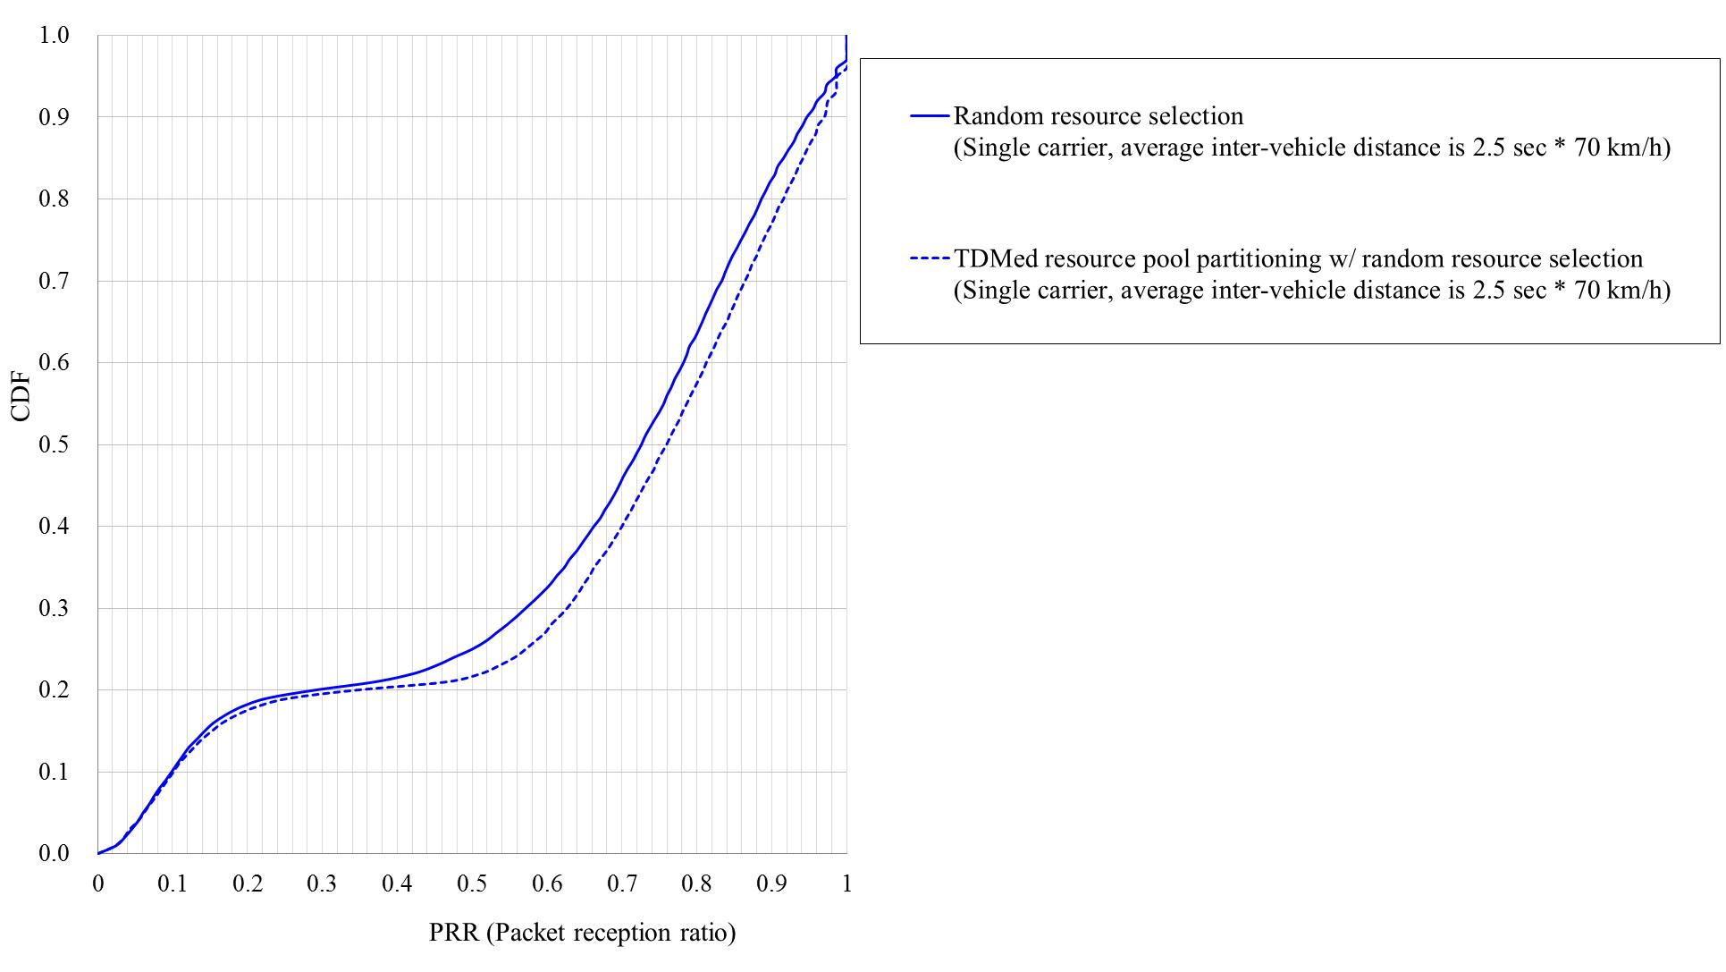

Fig. A-2 CDF of PRR in the range of [0, 320]m (i.e., freeway case, 70km/h)

Table A-3. Average PRR in the urban case (60km/h)
Range (m) | Random resource selection | TDMed resource pool partitioning w/ random resource selection | Gain [%]
0 ~ 20 | 0.7921 | 0.7777 | -1.82
20 ~ 40 | 0.7833 | 0.7721 | -1.44
40 ~ 60 | 0.7710 | 0.7588 | -1.58
60 ~ 80 | 0.7248 | 0.7341 | 1.28
80 ~ 100 | 0.6638 | 0.6925 | 4.32
100 ~ 120 | 0.5962 | 0.6394 | 7.25
120 ~ 140 | 0.5228 | 0.5727 | 9.54
140 ~ 160 | 0.4766 | 0.4886 | 2.51
160 ~ 180 | 0.4144 | 0.4222 | 1.87
180 ~ 200 | 0.3393 | 0.3586 | 5.70
200 ~ 220 | 0.2971 | 0.2732 | -8.04
220 ~ 240 | 0.2548 | 0.2065 | -18.99
240 ~ 260 | 0.0968 | 0.0856 | -11.64
260 ~ 280 | 0.0884 | 0.0752 | -14.97
280 ~ 300 | 0.0994 | 0.0766 | -22.91
300 ~ 320 | 0.0957 | 0.0781 | -18.37
320 ~ 340 | 0.0920 | 0.0678 | -26.25
340 ~ 360 | 0.0841 | 0.0644 | -23.42
360 ~ 380 | 0.0807 | 0.0648 | -19.61
380 ~ 400 | 0.0741 | 0.0568 | -23.38
400 ~ 420 | 0.0644 | 0.0423 | -34.35
420 ~ 440 | 0.0455 | 0.0228 | -49.85
440 ~ 460 | 0.0435 | 0.0201 | -53.76
460 ~ 480 | 0.0379 | 0.0197 | -48.05
480 ~ 500 | 0.0255 | 0.0131 | -48.70
500 ~ 520 | 0.0164 | 0.0098 | -40.18

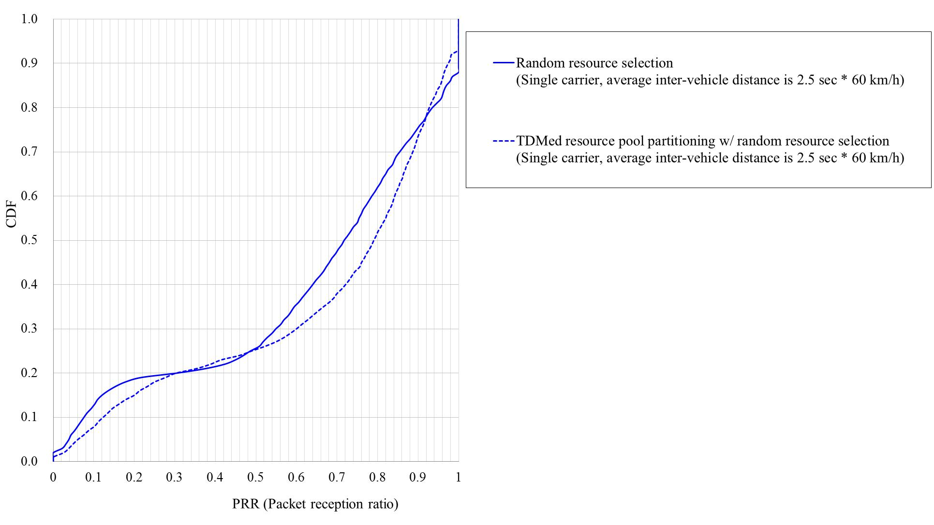

Fig. A-3 CDF of PRR in the range of [0, 150]m (i.e., urban case, 60km/h)

Table A-4. Average PRR in the urban case (15km/h, message generation period of ‘100ms’)
Range (m) | Random resource selection | TDMed resource pool partitioning w/ random resource selection | Gain [%]
0 ~ 20 | 0.7944 | 0.7771 | -2.18
20 ~ 40 | 0.7534 | 0.7107 | -5.67
40 ~ 60 | 0.6459 | 0.5709 | -11.62
60 ~ 80 | 0.5022 | 0.4208 | -16.19
80 ~ 100 | 0.3562 | 0.3047 | -14.44
100 ~ 120 | 0.2431 | 0.2309 | -5.02
120 ~ 140 | 0.1745 | 0.1705 | -2.25
140 ~ 160 | 0.1240 | 0.1338 | 7.90
160 ~ 180 | 0.0855 | 0.1074 | 25.63
180 ~ 200 | 0.0600 | 0.0846 | 40.98
200 ~ 220 | 0.0423 | 0.0628 | 48.61
220 ~ 240 | 0.0292 | 0.0351 | 20.13
240 ~ 260 | 0.0087 | 0.0167 | 91.46
260 ~ 280 | 0.0071 | 0.0138 | 94.30
280 ~ 300 | 0.0058 | 0.0143 | 146.54
300 ~ 320 | 0.0044 | 0.0166 | 274.73
320 ~ 340 | 0.0032 | 0.0177 | 444.48
340 ~ 360 | 0.0024 | 0.0176 | 640.83
360 ~ 380 | 0.0018 | 0.0141 | 678.96
380 ~ 400 | 0.0014 | 0.0103 | 650.54
400 ~ 420 | 0.0009 | 0.0058 | 557.23
420 ~ 440 | 0.0005 | 0.0018 | 229.00
440 ~ 460 | 0.0004 | 0.0008 | 86.85
460 ~ 480 | 0.0003 | 0.0008 | 161.64
480 ~ 500 | 0.0002 | 0.0011 | 538.81
500 ~ 520 | 0.0001 | 0.0013 | 1340.64

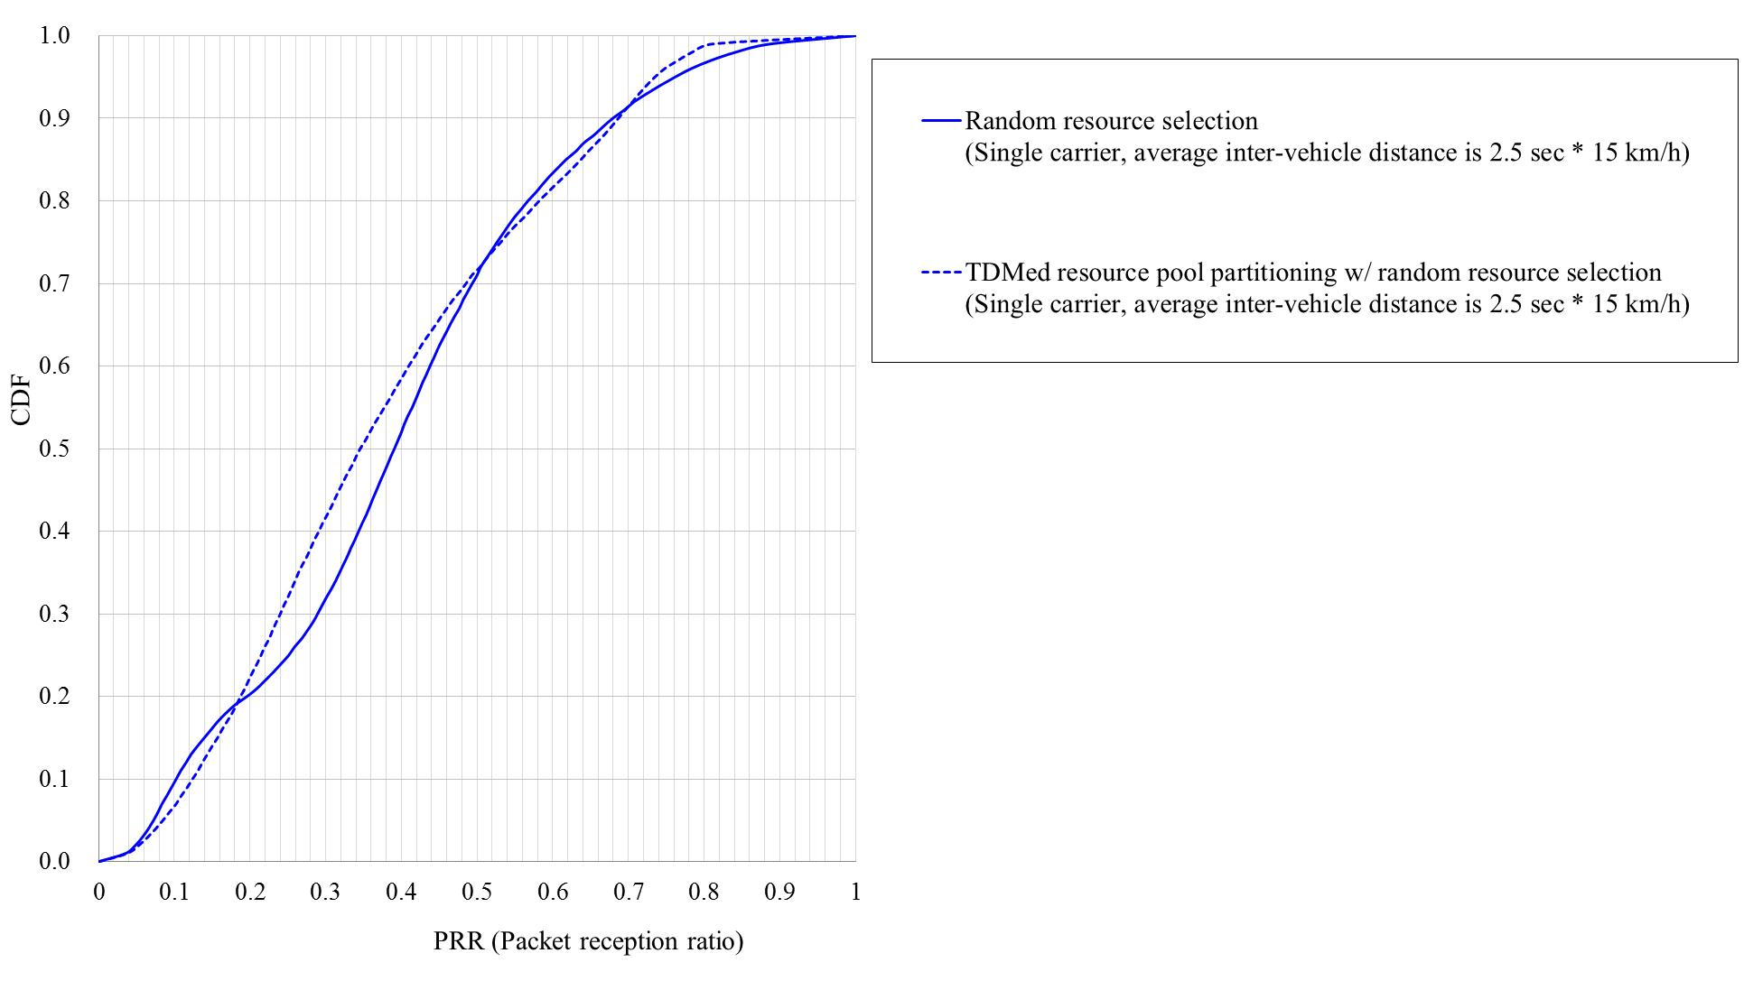

Fig. A-4 CDF of PRR in the range of [0, 150]m (i.e., urban case, 15km/h, message generation period of ‘100ms’)

